Sonja Mejcher-Atassi

**Jabra, Ibrahim Jabra (1920-1994)** 763 words

Born in Bethlehem, Palestine, in 1920, Jabra was a distinguished intellectual whose literary writing, translation, and criticism played an important role in Arab cultural life in the second half of the twentieth century. He can be described in many ways: A renaissance man, a modernist, a humanist, an intellectual, a university professor, a literary writer, a poet, a novelist, a translator of Shakespeare and Faulkner, a painter, an art critic, a founding member of the Baghdad Group for Modern Art, a lover of music, and a Palestinian exile in Iraq. Jabra’s contribution to modern art was in three ways: as a founding member of the Baghdad Group for Modern Art in 1951 together with the Iraqi artists Jewad Selim and Shakir Hassan Al Said, an art critic, and an artist. Jabra writes about his first encounters with art, and more broadly visual culture, in his autobiography *al-Bi’r al-ula* (*The First Well*, 1987). Most of his paintings done in Iraq were destroyed with his house in 2010. Jabra’s main contribution however has to be seen in his writings as an art critic, especially his publications *Jawad Salim wa-nasb al-hurriyya* (*Jewad Selim and the Monument of* Freedom, Baghdad 1974) and *al-Fann al-‘iraqi al-muasir* (*Iraqi Art Today*, Baghdad 1970) with which he introduced modern art in Iraq to a broader public.

After graduating from the Arab College in Jerusalem, Jabra went on a scholarship to study English literature at Cambridge University (1939-43). On his return, he worked as a teacher and organised cultural activities at the Arts Club of the YMCA in Jerusalem. The creation of the state of Israel in 1948, referred to in Arabic as the *nakba* (catastrophe), forced him into exile. He found a job at Baghdad University and embarked on a new life in Iraq at a time of radical socio-political as well as cultural change. Apart from two years at Harvard University in the early 1950s and occasional trips abroad, he remained in Baghdad, later as counsellor at the Iraqi Ministry of Culture and Information, until his death in 1994. In 2010, his house was destroyed in car bomb explosions that targeted foreign embassies in Baghdad, an event that was considered by some a deathblow to Baghdad’s cultural memory.

An important influence was Jabra’s teacher, the Palestinian artist Jamal Badran who had studied Islamic art in Cairo. It was in England that Jabra started to paint in oils. Some of his early paintings, dating back to before 1948, were rediscovered recently in Bethlehem and have triggered some research, placing him among the pioneers of modern art in Palestine. He also wrote for numerous cultural journals devoted to modern literature and art, such as *Shi’r* (Beirut), *Gilgamesh* (Baghdad), *Ishtar* (Paris), and *Ur* (London). As a founding member of the Baghdad Group for Modern Art, he was greatly interested in the relationship between past and present, reconfigured as modernity (*hadatha*) and heritage (*turath*). It was the quest for an Arab modernism that for Jabra held promises of individual freedom and political liberation.

**References and further reading:**

Al Ama, George and Atrash, Nada (May 2012) “Reflections on the Palestinian Art Movement before 1948: the Paintings of Jabra Ibrahim Jabra,” *This Week in Palestine* no. 169, http://www.thisweekinpalestine.com/details.php?id=3710&ed=206&edid=206.

Boullata, Issa, *Nafidha ‘ala al-hadatha: Dirasat fi adab Jabra Ibrahim Jabra* (Window to Modernity: Studies on the Literature of Jabra Ibrahim Jabra) (2002)Beirut: al-Mu’assasa al-‘arabiyya lil-dirasat wal-nashr.

Boullata, Issa (22.03.2001) “Living with the Tigress and the Muses: An Essay on Jabra Ibrahim Jabra,” *World Literature Today*.

Boullata, Kamal, *Palestinian Art: From 1850 to the Present*, London: Saqi Books, 2009.

Greenberg, Nathaniel (2010) “Political Modernism, Jabra, and the Baghdad Modern Art Group,” *CLCWeb: Comparative Literature and Culture* 12.2,

http://dx.doi.org/10.7771/1481-4374.1603.

Mejcher-Atassi, Sonja (2012) *Reading across Modern Literature and Art*, Wiesbaden: Reichert (literatures in context 34).

Munif, Abd al-Rahman (ed.) (1995) *al-Qalaq wa-tamjid al-hayat: Kitab takrim Jabra Ibrahim Jabra* (Anxiety and Praise for Life: A Book in Honour of Jabra Ibrahim Jabra) Beirut: al-Mu’assasa al-‘arabiyya lil-dirasat wal-nashr, 1995.

**Jabra’s writings on art:**

(1970) *al-Fann al-‘iraq al-mu’asir/Iraqi Art Today*, Baghdad: Wizarat al-i’lam (al-silsila al-fanniyya 15).

(1974) *Jawad Salim wa-nasb al-hurriyya: Dirasa fi atharihi wa-ara’ihi* (Jewad Selim and the Monument of Freedom: A Study on his Works and Ideas), Baghdad: Wizarat al-i’lam.

(1983) *The Grass Roots of Iraqi Art*, Baghdad: Addar al-Arabiah.

(1986) *Judhur al-fann al-‘iraqi* (The Grass Roots of Iraqi Art), Baghdad: al-Dar al-‘arabiyya lil-tiba’a wal-nashr.

(1988) *A Celebration of Life: Essays on Literature and Art*, Baghdad: Dar al-Ma’mun.

(2000) *al-Fann wal-fannan: Kitabat fi al-naqd al-tashkili* (Art and Artist: Writings in Art Criticism),ed. Ibrahim Nasrallah, Beirut: al-Mu’assasa al-‘arabiyya lil-dirasat wal-nashr.

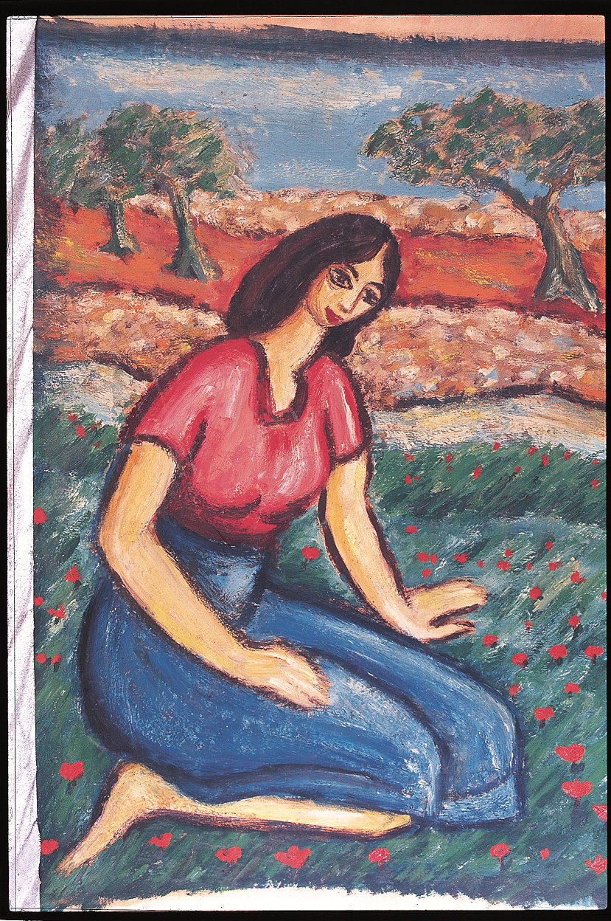

*Field of Anemones*, 1947, oil on canvas, 44x29 cm.

Kamal Boullata (2009) *Palestinian Art: From 1850 to the Present*, London: Saqi Books, 2009, p. 94.